Sample 4

Q1(a) The java application outlined in Figure 1 is single threaded and results in the
output shown in Figure 2.

Rewrite the application using Java Concurrency Framework, replacing the
‘display’ method with ‘run’, ensuring that the threads run concurrently and the
resulting output is similar to that shown in Figure3.

class Display {
public String name;
public Display(String nm){
name=nm;
}
public void display(){
for(int i=0; i<4;i++)
{ System.out.println(name+": "+i);
try{ Thread.sleep(1000);}
catch(Exception e){}
}
}
}

public class Q1a
{
public static void main(String[] args)
{
Display d1=new Display("First");
Display d2=new Display("Second");
d1.display();
d2.display();
}
}

Figure 1

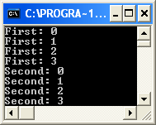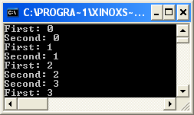
Figure 2 Figure 3

(8 Marks)
Q1.(b) The Java application (included in appendix 1) is a simple Producer Consumer
Application. The Producer thread stores values in the Numberstore while the Consumer
reads those values from the same Numberstore as shown.

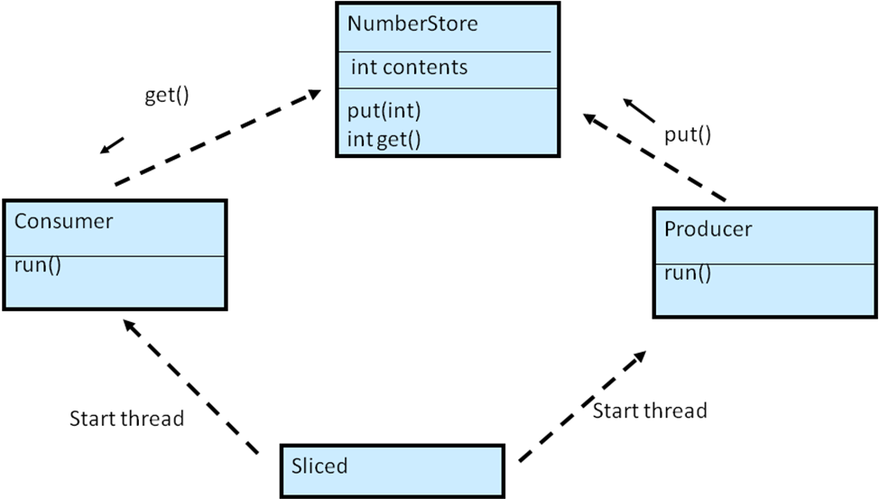

(i) Explain briefly why each of the following sequences might occurs.

Sequence1 Sequence2
Consumer #1 got: 3 Producer #1 put: 4
Producer #1 put: 4 Consumer #1 got: 4
Producer #1 put: 5 Consumer #1 got: 4
Consumer #1 got: 5 Producer #1 put: 5

(3 Marks)

- Outline a new ‘synchronized’ version of the ‘NumberStore’ to ensure the application is well-behaved

(9 Marks)
[20 marks]

Q2(a) We want to use Hashing techniques to store a group of N Nodes into an array with LEN
Slots.

0 1 2 3 LEN-1

- Complete the following Java code implementation for a simple Hash function that will
map an integer key to an index value in the range 0..N
static int hash(in key){
}
(2 marks)

- Explain what is meant by Collision Detection and demonstrate using diagrammed
examples how Linear Probing can be used to resolve collisions.

(4 marks)
(iii) An Java implementation for the sequential search is outlined in Figure 4.

Provide a proof that the performance of a successful search is

~ O( (N+1)/2) )
(6 marks)
public static boolean search(int[] list,int target){
for(int i=0; i<list.length; i++){
if(list[i] == target) return true;
}
return false;
}

Figure 4

(b) Given the following incomplete Java application which uses the HashSet Collection
public class Q2b
{
static boolean search(HashSet set,int target){….
static int countEven(HashSet set){…

public static void main( String[] args )
{ HashSet<Integer> set = new HashSet();
Collections.addAll(set , 4,5,3,2,3,1,3,8,9,11);
print(set);
int target=Console.readInt("Enter Target:");
System.out.println("Element Found="+ search(set,target));
System.out.println("No of Even Elements="+countEven(set));}
}

Outline a java implementation for the two functions

- boolean search(HashSet set, int target) // returns true if ‘target’ is in the set

- int countEven(HashSet set) // return the number of even elements

(8 marks)
[20 Marks]
Q3(a) The following class defines an array of integer values and has member functions to
access the array as shown:

class ArrayTest
{
private int[] values;
public ArrayTest(int[] v)
{
values = v;
}
public int first()throws Exception
{
if (values.length == 0) throw new Exception();
return values[0];
}
public int max()throws Exception
{
if (values.length == 0) throw new Exception();
int res = values[0];
for (int i=0;i< values.length;i++)
{
if (res< values[i]) res = values[i];
}
return res;
}

public void printAll()
{
System.out.println(); System.out.print("[");
for (int i=0;i< values.length;i++)
System.out.print(" " + values[i]);
System.out.println("]");
}
}

An object of this type can be defined and used as follows:

int[] a = { 2, 6, 3, 5 };
ArrayTest at = new ArrayTest(a);
int res1 = at.first();
System.out.println("First=" + res1);
int res2 = at.max();
System.out.println("max=" + res2);
at.printAll();

- Use java Generics to rewrite the ‘ArrayTest’ class so it can be used with any numeric type ‘int’, ‘float’, ‘double’ etc

- Outline code that defines and uses an object of this new class.

(11 Marks)

(b) Given the following incomplete Java application which uses the ArrayList Collection
public class ArrayList1
{
static int sum(ArrayList list){ // to be completed
}

public static void main( String[] args )
{
ArrayList<Integer> list = new ArrayList();
Collections.addAll(list , 6, 3, 1, 4);
int res1=sum(new ArrayList(list));
System.out.println("Sum of all elements=" +res1);
}
}

Outine a java recursive implementation for the function

static int sum(ArrayList list)

which returns the sum of all element in the list

i.e. sum([6,3,1,4]) returns 14

(9 Marks)
[20 Marks]

Q4 The Java application included in Appendix 2 has a class Match which records the names
of the teams and the score of a football Match.

Menu
---------------
1.City Score
2.United Score
3.Print Details
4.Exit
Please enter a value--> 3

Score:
-------------
City United
1 0

Currently the only available functionality allowed is to record one of the teams scoring a
Goal and to print the current score as shown.

Show how the Visitor pattern could be used to add the following additional
functionality, without introducing the new functionality directly into the Match class:

New Functionality:

void resetMatch() - reset score to 0 0

String readResult() - 3 possible results
CITY WIN
UNITED WIN
DRAW
[20 marks]

Appendix 1

class Producer extends Thread {
private NumberStore store;
private int number;
public Producer(NumberStore ns,int n){store=ns;number=n;}
public void run() {
for (int i = 0; i < 10; i++) {
store.put(i);
System.out.println("Producer #"+ this.number + " put: " + i);
try {
sleep((int)( Math.random()*10)); }
catch (InterruptedException e) {} }
}
}

class Consumer extends Thread {
private NumberStore store;
private int number;
public Consumer(NumberStore ns,int n){store=ns;number=n;}
public void run() {
int value = 0;
for (int i = 0; i < 10; i++) {
value = store.get();
System.out.println("Consumer #" + this.number
+ " got: " + value);
try { sleep((int)( Math.random()*10));}
catch (InterruptedException e) {} }
}
}

class NumberStore {
private int contents=0;
public int get() {
return contents; }
public void put(int value) {
contents = value; }
}

public class Sliced1 {
public static void main(String[] args)
{
NumberStore ns=new NumberStore();
Producer p=new Producer(ns,1);
Consumer c=new Consumer(ns,1);
p.start();
c.start();}
}

Appendix 2

public class Match {
private String team1;
private String team2;
private int score1;
private int score2;
public Match()
{
this.team1="City";
this.team2="United";}
public void team1_score()
{ score1++;
}
public void team2_score()
{ score2++;
}
public void print_score(){
System.out.println("\nScore:");
System.out.println(""+team1+"\t"+team2);
System.out.println(" " +
""+score1+"\t "+score2);}
}
public class MatchTest {
public static void main(String[] args) {
Match m=new Match();
int choice = 1;
while(choice!=5)
{
System.out.println();
System.out.println("1.City Score");
System.out.println("2.United Score");
System.out.println("3.Print Details");
System.out.println("4.Exit");
choice = Console.readInt("Please enter a value-->");
if(choice==1)
{ m.team1_score();
}
else if(choice==2)
{ m.team2_score();
}
else if(choice==3)
{ m2.print_score();
}
} // end while
}

}

